National Taiwan University
New Employee Physical Examination Consent Form

To ___________________________ (name of Hiring Unit), National Taiwan University:
I, the undersigned, understand that I have received an offer of employment on __________________________ (date) with _________________________________ (name of Hiring Unit) at National Taiwan University and I also understand that I am required to comply with the provisions of Article 20 of the Occupational Safety and Health Act and of Article 16 of the Labor Health Protection Regulations.

I hereby agree to complete the physical examination for new employees prior to my first day reporting to work and to submit my physical examination report to the Hiring Unit by ______________________ (date). The University agrees to retain a copy of this report with due care and to protect my privacy in accordance with the Personal Data Protection Act. I also understand that failure on my part to complete the physical examination or submit the examination report may result in the violation of relevant laws and regulations and as a result I may be subject to administrative penalty, in which case I shall bear all relevant legal responsibilities.

Agreed to by: __________________________________ (signature)

Telephone: ____________________________________

Date: _________________________________________

Will you be undertaking “tasks with special health hazards” at National Taiwan University?  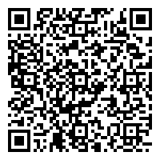  (Refer to the following website for additional information: https://reurl.cc/anZVW9) | □ Yes; Category:  (Please proceed with the required special physical examination  for this category)  □ No

